Who Is Onboard in
GA and Air Taxi Accidents:

Implications for Child Restraint Systems
& Other Issues in General Aviation

Annual ISASI Seminar
September 2011
Salt Lake City

Robert Matthews, Ph.D.
Senior Safety Analyst
Federal Aviation Administration

In December 2010, the U.S. National Transportation Safety Board (NTSB) hosted the Forum on Child Safety, where the proper use of child restraint systems (CRS) was a central issue. Most of the Forum addressed child safety and CRS in road transport and in airline operations, but Board Members posed a simple question about general aviation (GA) and the air taxi system: how many infants might benefit from a requirement to use CRS in GA and air taxi operations? FAA and NTSB staff, and everyone else, could respond only with speculation and anecdotes. No one had real information on who travels in the system.

Board Members had asked a basic question that merits a response. However, to respond knowledgeably, we first needed to know how many infants travel in the system and how many infants had been involved in accidents, and what their outcomes were. We knew none of that. In fact we knew little generally about infants or others who travel in the GA system.

Despite substantial improvements in data collection, data quality, and analytical procedures throughout the aviation community, one-off issues often defy such systems. In this case, we were unable to respond to a basic question about who travels in the GA system and who is thereby exposed to risk. Appropriate data could provide a definitive answer to the issue that the Board Members tried to explore on CRS in GA, and it could inform other policy issues in GA.

This paper presents new data that begins to answer the question of who is flying and traveling in GA and air taxi operations, and who is thereby exposed to risk, and it definitively answers the specific questions about infants. The paper is organized into three parts. Part One describes existing data and how the data for this paper was compiled. That data initially was compiled for the US, but similar data was compiled for Australia to judge whether U.S. findings might have some broader application. Part Two presents the newly compiled data and applies it to the issue of CRS in GA. Part 3 applies the data to 2 other examples in GA in the US, then examines whether the US findings are consistent with experience elsewhere.

Data Collection

The data search was undertaken to answer the basic question of who is on board aircraft involved in fatal accidents. Any such effort normally would rely on official accident data. However, NTSB and FAA systematically collect data only on pilots, with data on pilot gender, age, and experience (flight hours and ratings). Data on pilots’ age and gender is quite good, particularly in fatal accidents, but even that data has holes in it.

First, if a study includes recent accidents, official information on pilots will be scarce, since that data is rarely available in preliminary reports. Similarly, data for pilots of US-registered aircraft that crash outside the US is very weak, as that data is rarely recorded in U.S. accident databases. In some other cases, regardless of the status of an investigation, data fields simply are not populated. This is especially common in non-fatal accidents and for second pilots who are onboard. The bottom line for basic data on pilots is a somewhat guarded endorsement: the data has weaknesses but it usually is good enough, at least with fatal accidents.

However, in addition to the occasional hole in pilot data, we have no systematic data on passengers. It simply does not exist. Therefore answering the simple question of who is on board GA and air taxi aircraft required sources other than official data. The best alternative source in the U.S. is the popular press. Local press organizations routinely report at least briefly on virtually every fatal accident, and routinely include passing references to age and gender for all occupants, including most survivors.

Data collection began with a tedious search of domestic and foreign press reports on all fatal accidents. The search was limited to fatal accidents because press reports are not as universally available for non-fatal accidents, especially in low-risk events, and where reports are available, they generally provide less information. The objective of the search was to identify the age and gender of every occupant on-board every US-registered aircraft that was involved in a fatal accident during GA and air taxi operations, whether occupants were injured or not. Obituaries and coroners’ reports filled some gaps, as did accident reports from foreign investigative authorities. Only suicides and balloon accidents were excluded from the search.

The search started with fatal accidents at the end of March 2011 and worked backwards. Press articles on recent fatal accidents are relatively easy to find but as time passes, articles become increasingly harder to find. Consequently, the search terminated at June 1, 2004. By that point, the marginal benefit of adding one more accident to the dataset no longer justified the effort. However, because press reports on recent cases are relatively easy to find, the dataset then was updated to capture fatal accidents in April and May 2011. The result was 7 full years of data from mid-2004 through mid-2011.

The desired information was available for all but a small number of fatal accidents, such as some accidents that occurred abroad where custom or privacy laws limited the information. However, even in some of those cases, enough information was available to aid in a search of U.S. press reports. In many other cases, depending on the country, foreign press reports or accident reports provided the information in a straight forward manner. In another handful of cases, age was estimated based on other information that was noted in press coverage, such as when someone graduated from a local high school, or the age of a spouse.

The approach was low-tech and tedious, but it has produced data on occupants in fatal GA and air taxi accidents in the U.S. over 7 years. Age and gender were identified for 4,232 occupants on 2,114 aircraft in fatal accidents over 7 years, including 2,262 pilots and 1,970 passengers.

Data Results and CRS in GA

The compiled data enables us to replace speculation and opinion with some facts in our response to the original questions that stimulated the search. Figure 1 shows the age distribution for all occupants, including pilots, on GA and air taxi aircraft in fatal accidents over the 7-year study period. The Figure shows that just 9 infants younger than 2 years of age, some of whom were properly secured, were among the 4,232 occupants. This is a hard count, not an estimate. The 9 infants were carried on just 8 aircraft, including 3 medical flights. Just 6 infants were onboard a total of 5 personal or private flights in fatal accidents in 7 years.

The bottom line is that, in a typical year, we can expect 1 fatal accident in which an infant is onboard. This will include properly secured infants and some unsecured infants who are involved in non-survivable events. This data indicates that the opportunity for a new CRS rule to produce a “save” is very limited. The same data suggests that infants do not travel in the system in large numbers. Given the distribution of activities within GA and air taxi operations, we can estimate that about 35,000 infants, both secured and unsecured, travel in the system every year. To put this number in scale, the U.S. air carrier system carries over 20,000 lap infants per day.

The number of infants involved in fatal accidents may seem surprisingly low. If so, the surprise might reflect a tendency to discuss GA and air taxis in a manner that suggests each is a single, coherent set of activities. In fact each is a collection of very different activities with significant differences in fleets, classes of pilots, demographics, and flight environments. For example, we would not expect to find infants on fire-fighting or other aerial application flights, instructional flights, aerobatic flights, off-shore flights to and from oil rigs, cargo operations in light aircraft, heavy lift operations, most corporate and business flights, etc.

Instead, infants’ presence on aircraft is limited to medical flights and family travel in private or chartered aircraft. As Figure 2 implies, family travel is limited in GA and air taxi operations. For example, single pilots flying alone accounted for 43.6 percent of fatal-accident aircraft over the 7 years, while instructional and other flights with 2 pilots and no passengers accounted for another 4.9 percent. A few more aircraft carried 3 lone crew members. In short, nearly half of all fatal-accident flights (48.6 percent) carried pilots only. In addition, single pilots with single passengers accounted for 29 percent of the 2,114 aircraft. Assuming that single pilots are unlikely to fly with infants in their laps, nearly 78 percent of all aircraft in fatal accidents have no opportunity to carry infants. In fact, no infants were on board any accident aircraft that had 3 or fewer occupants, which account for 88.4 percent of all aircraft in fatal accidents.

Of the 9 infants onboard in 8 fatal GA and air taxi accidents over 7 years, all 9 were killed, as were all but 1 of the 57 occupants onboard those aircraft. Below is a brief summary of the 8 fatal accidents.

  - A Part 135 (air taxi) emergency medical helicopter carrying an infant patient struck a radio tower. All 4 occupants were killed, including the infant.
  - A Part 135 emergency medical helicopter carrying an infant patient flew into mountainous terrain during a night VFR operation. All 5 occupants were killed, including the infant and the infant’s mother.
  - A fixed-wing, Part 135 ambulance aircraft flew into high terrain. All 5 occupants were killed, including an infant.
  - A PA-60-601P on a personal (private) flight crashed shortly after takeoff in high density-altitude. All 5 occupants were killed, including an infant and a toddler.
  - An over-weight Lancair crashed on a personal (private) flight during a go-around. All 6 occupants on the 4-seat aircraft were killed, including an infant and another child just past her second birthday.
  - A 10-seat Pilatus with 14 occupants on a personal flight crashed on approach. All 14 occupants were killed, including 7 adults, an infant, a pair of 3-year-olds, plus children of 4, 5, 7 and 9 years of age.
  - A father with 107 hours took off VFR in severe weather in a Cessna 401, lost control and crashed nose down. All 7 occupants were killed, including a new-born infant, a second infant less than 2 years of age, and a 3-year-old child.
  - A Cessna 172 on a personal flight was involved in a mid-air collision during flare to land. Of the 4 occupants, impact and severe fire killed the pilot, a properly secured infant and a properly secured 6-year-old; a properly-secured 3-year-old was the sole survivor. Had that child not been properly secured, he likely would not have survived.

Though some of the 9 infants were secured and some were not, a requirement to use child restraints would have prevented none of the 9 infant fatalities over 7 years. However, the sole survivor in those 8 accidents was a properly secured 3-year-old toddler. Though his father and properly secured brothers died, the survival of the 3-year-old illustrates that proper use of a CRS can produce some benefit in GA and air taxi operations.

A total of 22 toddlers were onboard the 2,114 fatal-accident aircraft. Of those 22 toddlers, 19 died. As with infants, some toddlers were properly secured and some were not. Since existing rules required toddlers to be properly secured, a new rule on CRS for infants would not affect outcomes for these children. However, in addition to the toddler save noted above, two other outcomes illustrate the possible benefits of properly securing young children in small aircraft.

- A Socata TBM-700 (850) crashed on initial climb-out at Iowa City on an IFR Part 91 Angel Flight, carrying a 3-year-old. The pilot and the child’s mother were seriously injured. The child was fatally injured. The child’s mother later explained that she had used angel flights for some time. Until her daughter was 2 years old, the mother had used a "child carrier," which she placed on the floor in front of her. As the child got bigger, the mother carried the child unsecured on her lap since her daughter would not have fit properly in a seat with a shoulder harness. On impact, the mother lost control of the child and the child was killed on impact. NTSB cited the lack of a CRS as a factor in the severity of the outcome. Existing requirements that applied to the child were not observed. With the use of a CRS, this was an avoidable fatality.

- A Cessna 206 with a 2-year-old and a 4-year-old, plus 2 adults and a 16-year-old, crashed shortly after rotation. The aircraft had been loaded “floor to ceiling” with lumber, ceramic tile, cement, groceries and luggage. The 4-year-old sat unrestrained in the mother’s lap in the right front seat. The 16-year-old, who described her pre-takeoff position as being squeezed into a rear seat, held the 2-year-old in her lap. Before takeoff, witnesses described tires as being nearly flat and discussed among themselves how badly over-loaded the aircraft appeared to be.

After loading his family onto the aircraft, the pilot took off and the aircraft immediately rolled and crashed. The mother lost control of the 4-year-old, who became pinned beneath the control panel by the shifting load and died in the intense post-crash fire. Though all other occupants were severely burned, all 4 survived. The unsecured 2-year-old survived largely because he was “pinned in” and was constrained by default. The use of a proper restraint system almost certainly would have saved this 4-year-old child.

In sum, proper adherence to existing rules and the use of proper restraints did or could have saved 3 toddlers’ lives over 7 years. In addition, a 5-year-old was saved by having been properly restrained when a Cessna 172M landed long on a grass strip in Rimrock, Washington and crashed into a home during a go-around. The pilot died on impact, as did his 13-year-old son in the right front seat. The sole survivor was a 5-year-old boy, who was found strapped into a child safety seat that was suspended upside down in the aft cabin of the inverted fuselage, with the CRS attached to the rear seat belt restraint. This was a save.

These cases show that the proper use of restraints can produce real benefits for small children, but many of the cases also indicate the practical limitations that can limit the effectiveness of any regulators. The Pilatus noted above carried 14 people in a 10-seat aircraft, with 7 young children, including an infant. Similarly, the over-weight, 4-seat Lancair carried 6 people, including an infant and a toddler. The Cessna 401 noted above took off VFR in severe weather with 7 occupants, including 2 infants and a toddler. The Cessna 206 noted above took off severely over-weight with an unsecured load and with 2 unsecured toddlers. If those 4 pilots had followed existing rules on seating requirements, or if they had simply observed basic airmanship and common sense in some cases, none of the 4 accidents would have occurred because the flights would not have taken off. A new rule on infants and CRS would simply have given each of these 4 pilots one more rule to ignore. To be effective, rules must be observed.

Nevertheless, actual and possible saves of toddlers illustrate that potential benefits from a new CRS rule on infants in GA would be real but modest. Proper use of restraints by toddlers did or could have saved a total of 3 lives among a small population over the 7-year study period. The ratio of infants to toddlers traveling in the system suggests that a CRS requirement over a longer study period could save 1 infant life in GA and air taxi operations every 9 to 10 years.

Press reports also confirm that, generally, people who travel with their families in private or chartered aircraft are affluent. In fact they are very affluent. Presumably, those people already own some type of CRS for travel in cars and, even if they had to purchase a new CRS, a one-off expenditure would not be a burden. Therefore the cost of requiring the use of CRS in GA and air taxi operations would be essentially zero. As a result, the required use of CRS on such flights would not affect modal choice, which is the source of FAA’s reluctance to require the use of CRS for infants in airline operations.

The bottom line, then, is a bit mixed for the basic question about how many infants could have been saved by requiring CRS in GA. First, the number of infants traveling in the system is modest, at a bit over 100 per day, including infants who are properly secured. On average, just 1 aircraft per year is involved in a fatal accident with an infant onboard, including secured infants and unsecured infants who are involved in non-survivable impacts. Second, among the 9 infants who were killed during the 7-year study period, a CRS requirement would have produced no infant saves. Yet, the risk outcomes for toddlers illustrate that CRS can make at least a modest difference and might save 1 infant about every 9 to 10 years, and do so at next to no net cost.

Data Results and Application to Other Issues and Other National Contexts

Figure 1 has displayed age for all occupants of U.S.-registered GA and air taxi aircraft involved in fatal accidents over the 7-year study period. Those occupants, of course, consisted of both pilots and passengers, and the demographics of the 2 groups are quite different.

Figure 3 displays gender for 2,262 pilots and 1,970 passengers. Data on gender is easily summarized: it is overwhelmingly male. Most observers would expect a strong gender bias among accident pilots, as women account for just 7 percent of licensed pilots in the U.S. However, females accounted for just 2.2 percent of the 2,262 pilots involved in fatal accidents over the 7-year study period. This suggests that the fatal accident rate for male pilots is 3 times higher than the rate for female pilots. The precise ratio would change slightly, depending on whether the average male pilot and average female pilot fly a comparable number of hours, but the end result is a very substantial disparity.

The gender bias among passengers is less dramatic than it is among pilots, but it remains very strong. Gender is democratic only among passengers who are 15 years of age and younger, where gender is essentially 50-50 (49 percent female and 51 percent male). However, the pattern changes at age 16, or roughly the point at which individuals gain more control over their travel decisions. From 16 years of age and thereafter, males account for 67 percent of all passengers. Overall, males account for 65 percent of all passengers and 83 percent of all occupants, or 5 of every 6 people onboard.

Figure 4 shows the distribution of age for pilots involved in fatal accidents over 7 years. Just 1 percent of the pilots are less than 20 years old and 9.5 percent of pilots in fatal accidents are less than 30 years old, while 11.2 percent are 70 years of age or older. The median age among pilots in fatal accidents over the 7 years was 53.6 years.

As might be expected, passengers generally are younger. As Figure 4 illustrates, people 70 or older account for just 4.8 percent of passengers (versus 11.2 percent of pilots). That age group is nearly 3 times more likely to be operating an aircraft than to be along for the ride. At the opposite end of the spectrum, 14.2 percent of passengers in fatal accidents are 19 or younger, though that age group accounts for nearly 27 percent of the general population.

All this balances out to produce a median age of 42.3 years for passengers and 53.6 years for pilots, versus a median age of 39.6 years among the general population of the U.S. The median age of all occupants in GA and air taxi aircraft is 49.3 years. In short, GA is not the domain of the young, whether we examine pilots, passengers, or both.

As the data above shows, for better or worse, GA is overwhelmingly a male domain. It also is dominated by an older population, especially among pilots but also among passengers. At a minimum, this should influence the types of messages that are developed for the countless outreach programs with which governments and others try to foster safety in GA. Those messages probably should be developed for male audiences. This clearly is the case for messages that target pilots, but it also is true of messages that target adult passengers.

Finally, this data can help us to assess the effectiveness of a recent policy initiative in which the FAA created a category in the FARs for Light Sport Aircraft (LSA) and a category of Light Sport Pilots. The rule had several basic objectives. First, it recognized that many so-called ultra-lights in fact exceeded the maximum power and weight (maximum of 55 knots and 254 pounds, or 115 kilos) that defined ultra-lights. Provided that owners registered these “fat ultra-lights” by a certain date, the rule gave owners the opportunity to make these aircraft legal.

Simultaneously, the rule was intended to encourage the development of low-cost, light aircraft that at least met some kind of standard. The aircraft would not be required to meet FAR Part 23 standards, but they had to be developed and produced according to a consensus among manufacturers, subject to approval of the consensus standards by the FAA. A second and equally important objective was to attract a new generation of pilots to aviation. Pilots needed only 20 hours of training and could “self-certify” that they were medically fit to operate an aircraft. In practice, people need only a driver’s license from any State government to establish their medical fitness.

Advocates of the new rules contended that the availability of capable and inexpensive aircraft would bring tens of thousands of new pilots into aviation. The hope was that many of these new pilots would continue flying and move into more substantial aircraft and more traditional flying regimes. In short, we could stimulate at least a modest boost to the pipeline of younger pilots to replenish some share of the dwindling pilot population.

The experience has been a bit more modest than what advocates expected. The U.S. Aircraft registry shows about 7,000 new light sport aircraft since 2005, including the so-called “fat ultra-lights” that already were flying. The net increase is perhaps 4,000 aircraft over 6 years in which the economy has experienced about equal periods of boom and bust. That volume is not insignificant, but it is hardly a rush of new aircraft into the system.

A rush of new, young pilots is even less evident. Light sport aircraft began entering the accident data in meaningful numbers about 18 months into the study period. Among the 105 pilots of LSA involved in fatal accidents in that period, the median age is 61 years old, versus 53.2 years for all other pilots. That is a significant difference; 25 percent of SLA pilots were 70 years of age or older, while just 7.6 percent were younger than 30 years of age. Most of the 105 pilots once held at least a private pilot rating and a valid medical certificate. On net, the new rule appears to have encouraged a move down-market rather than a rush of new entries. Though providing an alternative for older pilots who wish to continue flying may have merit in its own right, the rule has missed its targeted population.

Comparison to Australia

A similar data search was undertaken on fatal accidents in Australia to determine whether some of the information from the data search in the U.S. is consistent with experience elsewhere. Australia and the US in fact share several important characteristics. Each has a large land mass, with high concentrations of their populations in urban belts in coastal areas, including the Great Lakes in the US, and each country has very large areas that are sparsely populated. The two countries also have somewhat similar demographics, with an identical median age of 39.6 years.

The most obvious difference, however, is a sense of scale in population. The U.S. has about 310 million people versus about 22.5 million in Australia. That fundamental difference affects the number of fatal accidents. Consequently, to build a dataset that meets some standard of statistical validity, Australian accidents were searched for a slightly longer period than were US accidents: from mid-2002 through mid-2011. The respective fleet mixes constitute a second notable difference, as light helicopters are much more significant in the GA fleet in Australia than in the US. Helicopters typically account for 20 to 25 percent of all fatal accidents in Australia versus less than 10 percent of fatal accidents in the US.

With those similarities and differences in mind, a search of press reports identified gender, age and outcome for 274 individuals on 131 aircraft involved in fatal GA and air taxi accidents in Australia from January 2003 through mid-2011. Results were quite similar to those for the U.S. For example, aircraft in Australia averaged 2.08 occupants compared to 2.00 in the U.S. Single-occupant and two-occupant aircraft accounted for nearly identical shares of accident aircraft in the 2 countries. In Australia, 45 percent of the fatal accidents involved single-pilots flying alone, versus 44 percent in the U.S., and aircraft with just 1 or 2 occupants accounted for 78 percent of fatal accidents in each country. Therefore, only about 2 in every 9 flights in either country even has the opportunity to carry a lap infant. This, in turn, suggests that family travel in small aircraft is limited in both countries, which limits the likelihood that infants will be onboard.

Just 1 infant was onboard the 131 aircraft in fatal accident aircraft, or 0.36 percent of occupants versus 0.2 percent in the U.S. The same aircraft carried 1 of just 2 toddlers in Australia’s fatal accidents over 9 years. That accounted for 0.4 percent of occupants, versus 0.5 percent for toddlers in the U.S. Given the differences in the populations examined, these very small percentages are effectively the same in the 2 countries for both infants and toddlers. The difference in national populations, plus slightly higher per-capita aircraft ownership in Australia than in the U.S., suggest that about 4,000 infants likely travel in Australia’s system each year.

The lone infant onboard in the Australian fatal accidents was unsecured and was fatally injured. Unlike the 9 fatally injured infants in the U.S. accidents, this fatality could have been averted by a CRS. In that accident in Western Australia in 2006, a Cessna 172L crashed on approach to a private strip during severe turbulence. The aircraft had shoulder harnesses and lap belts for 2 seats in front and 2 lap belts in the rear. The pilot and an adult male in front used only their lap belts. Each suffered serious head and upper-body injuries, which were fatal to the passenger. In the rear, a secured 3-year-old girl incurred minor injuries, while a secured adult female was seriously injured. A fatally injured lap infant was found outside the aircraft. Australia’s ATSB determined that “inadequate restraint of some occupants likely increased the severity of their injuries.” Use of the shoulder harness could have saved the passenger’s life and minimized the pilot’s injuries, and use of a CRS could have saved the infant’s life.

Results for gender in the 2 countries also were essentially the same for pilots and for passengers as in the U.S. Males accounted for 95 percent of the 148 pilots involved in Australia’s fatal accidents, versus 98 percent in the U.S., and males accounted for 71 percent of passengers in Australia versus 67 percent in the U.S.

However, comparative results on age were mixed. Passengers were slightly younger in Australia than in the U.S., with a median age of 39 in Australia versus 42.2 in the U.S. However, the median age among pilots was considerably younger in Australia than in the U.S., with a median of 43 years among Australian pilots versus 53.6 years in the U.S.

The bottom line in this brief comparison of data compiled for Australia and the U.S. is that basic results, despite some differences, could help to inform certain policy questions in more than one country. This clearly is the case with the child restraint systems, which was the issue that first stimulated the data search.

Conclusions

Despite substantial improvements in data collection, data quality, and analytical procedures over the past decade or so, one-off issues often require less automated procedures. The issue of CRS in GA and air taxi operations is one example. Given the topic of the NTSB Forum in December of 2010, NTSB Board Members asked a basic and reasonable question: how many infants fly in the GA and air taxi system, and how many infant lives might be saved if CRS were required. The simple fact is no useful data existed to inform a response.

The data compiled for this paper answers those questions definitively, based on a search of press reports and other sources that identified age and gender for 4,232 occupants on 2,114 aircraft involved in fatal accidents over 7 years. First, infants do not travel in the GA and air taxi system in large numbers (about 35,000 per year). Second, over the 7-year study period, just 9 infants were onboard in 8 fatal accidents. That is, just 1 fatal accident per year has an infant onboard, whether secured or unsecured. All 9 infants were killed, but a CRS requirement would have saved no infants’ lives. Yet, data on toddlers suggests that CRS could produce at least a modest benefit for infants, assuming all were properly secured: about 1 “save” every 9 to 10 years, and at virtually no net cost. Despite some differences in national profiles, the data suggests that conclusions on CRS and infants are consistent with experience elsewhere.

The data also fills some weaknesses on pilot data, particularly for second pilots and for pilots involved in fatal accidents abroad in U.S.-registered aircraft. In addition, the same new data allows us to begin exploring other issues with better information. For example, we can better document the gender and age of pilots involved in fatal accidents. The data indicates that, particularly among pilots and even among adult passengers, GA is overwhelmingly a male-dominated activity. That has implications for how we communicate with pilots. The same data also suggests that at least one recent effort by FAA to stimulate new entry into aviation, via the light sport rule, has somewhat missed its target.

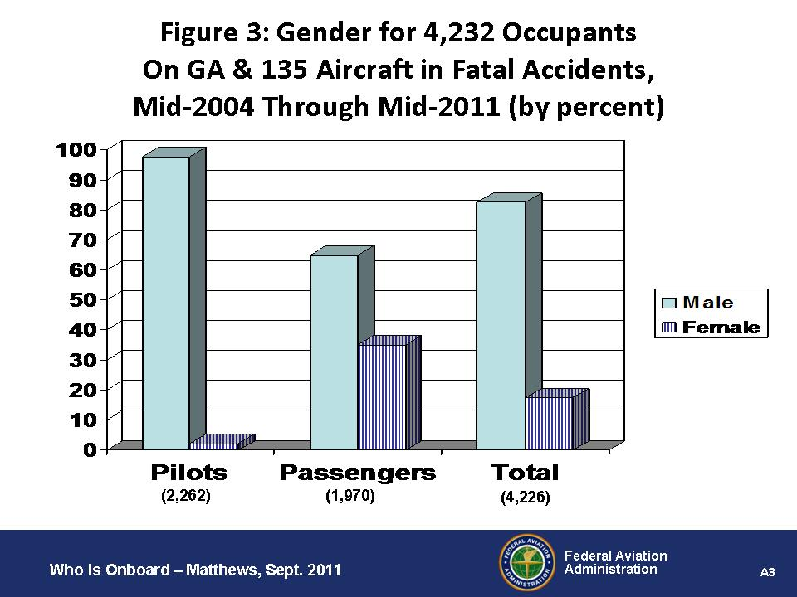

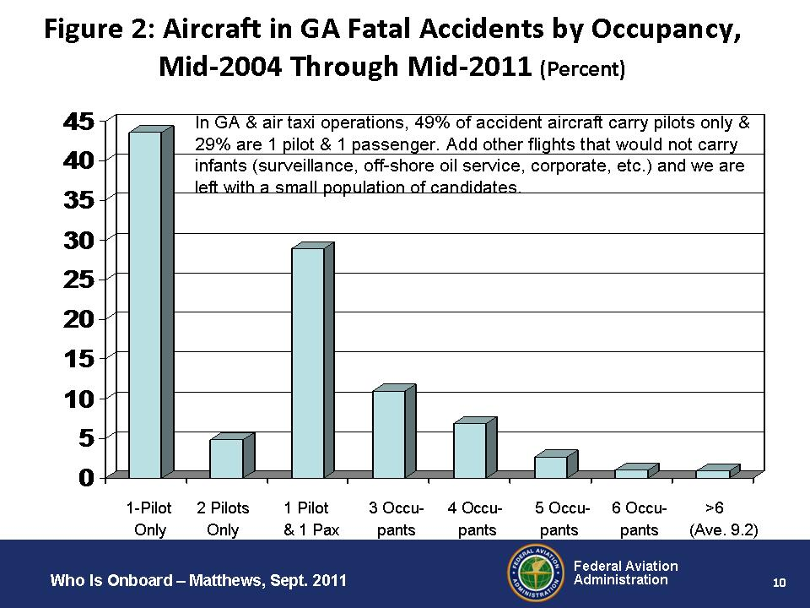

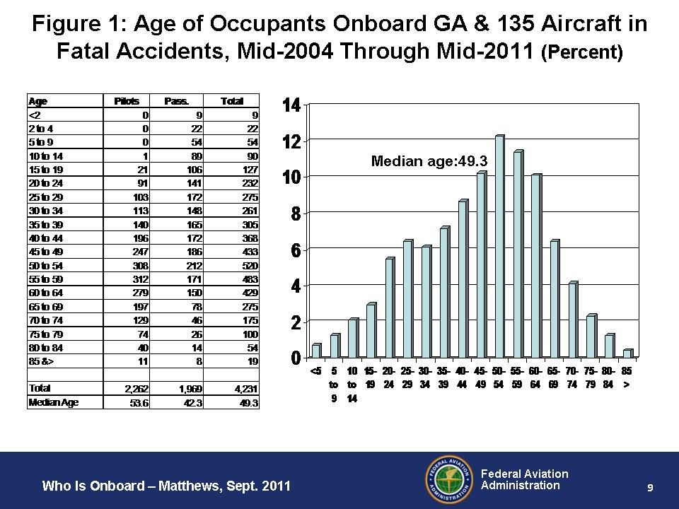

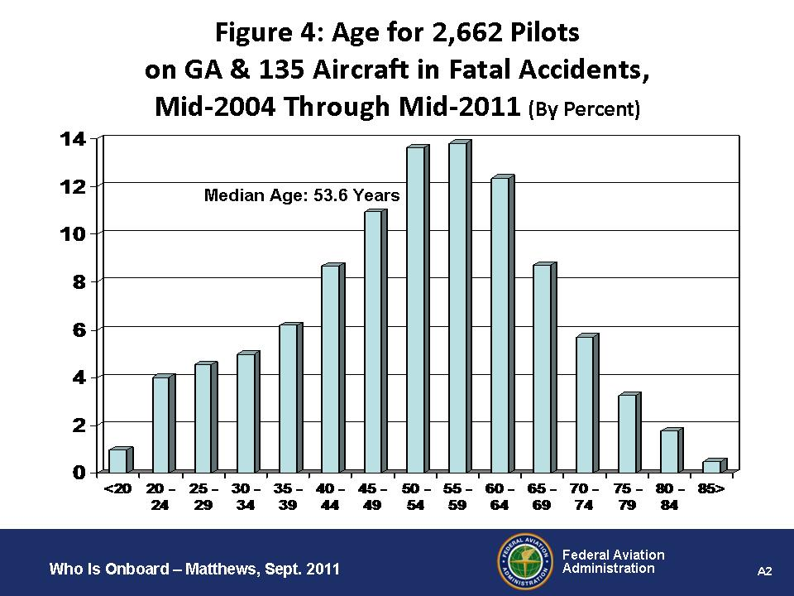

“Toddler” is defined here as children who have already reached their second birthdays but have not yet reached their fifth birthdays.
Requiring the use of CRS in airline operations would lead to a significant cost increases for families traveling with lap infants. For example, the cost of a flight would double for one adult traveling with an infant, and would increase by half for 2 adults traveling with an infant, and so on. Because price influences consumer choice in all economic transactions, FAA concludes that, within certain trip distances, large numbers of families traveling with infants would choose to drive, either to their original destinations or, for highly discretionary trips, to different destinations. With no infant “saves” in 17 years in air carrier operations, FAA estimates, conservatively, that this modal transfer would produce 6 to 8 extra fatalities per year, including infants and their family members. This issue does not apply in GA and air taxi operations for two reasons. First, the generally affluent families who travel by private or chartered aircraft would already own a CRS for travel by automobile and therefore would face no additional net cost. Second, even if a CRS rule imposed a net cost and a small number of those families abandoned their private or chartered aircraft and chose to drive to their destinations, they would not face higher risk because GA fatality rates in fact are slightly higher than fatality rates on high-design inter-city highways.

